Chapter 4

The role of within-host competition in coexistence in multiparasitoid-host systems

Ellen van Velzen, Saleta Pérez-Vila, Rampal S. Etienne

Summary
Multiparasitism (females of multiple species parasitizing the same host) is a ubiquitous phenomenon in parasitoids, yet the role of within-host competition has been mostly ignored in multiparasitoid-host models. Here we study the effects of interspecific between-adult and within-host competition on parasitoid coexistence. We adapt a Nicholson-Bailey model to allow for varying levels of both between-adult competition (varying the overlap in species distributions) and within-host competition (varying the number of offspring that can successfully emerge from the same host). We find that while stronger between-adult competition reduces coexistence, surprisingly stronger within-host competition promotes it. Asymmetric between-adult competition (a fecundity difference between the two species) reduces the opportunities for coexistence when compared to symmetric competition; this can be counteracted by asymmetric within-host competition (within-host competitive advantage of the lower-fecundity species), but only when within-host competition is strong and the correlation between the parasitoids’ distributions is not too weak or too strong. We discuss our results in the context of the interaction between two parasitoid species, Nasonia vitripennis and N. giraulti, which have strongly correlated distributions and high levels of multiparasitism in the field. We conclude that either low or asymmetric within-host competition are unlikely to explain their coexistence.

Introduction
To maximize their fitness, female parasitoids must choose their hosts in such a way that they maximize their offspring’s success (optimal oviposition theory, Jaenike 1978). In general, the optimal oviposition strategy is to exploit a host by herself, so her offspring will not have to share resources with competitors (Godfray 1994; van Baaren et al. 1994; Crespo and Castelo 2009). However, superparasitism (parasitizing a host already used by a conspecific female) can be an adaptive strategy (Charnov and Skinner 1984; van Alphen and Visser 1990; van Alphen et al. 1992), for example when hosts are scarce and searching for unparasitized hosts would be inefficient. Superparasitism is indeed frequently found in nature (van Alphen and Visser 1990; Godfray 1994; Dorn and Beckage 2007), and intraspecific host sharing (offspring of multiple females emerging from a single host) is ubiquitous in gregarious species.
In contrast, interspecific host sharing is very rare (reviewed in Harvey et al. 2013). Multiparasitism (parasitizing a host already used by a heterospecific female) is adaptive only under two scenarios: if the offspring of one parasitoid do not consume the entire host or do not require the entire host to develop (Miller 1982; Magdaraog et al. 2012), or if the multiparasitizing female has a competitive advantage over the first. The latter is the rule: one species wins within-host competition, and a range of mechanisms for eliminating competitors have been found in species faced with interspecific within-host competition (see e.g. Fisher 1963; Hagvar 1988; Chau and Maeto 2008; Harvey et al. 2013). So while multiparasitism is common, it rarely leads to interspecific host sharing.
Perhaps because interspecific host sharing is so rare, it has received relatively little attention in theoretical studies. Most multiparasitoid-host models assume either that one species always arrives first and the second species does not multiparasitize, or that one species is always competitively superior (May and Hassell 1981; Kakehashi et al. 1984; Klopfer and Ives 1997; Porter and Hawkins 2003; Lane et al. 2006; Kon and Schreiber 2009). In some other models the outcome of multiparasitism is decided by who arrives first (Hogarth and Diamond 1984; Hackett-Jones et al. 2009). Most of these models consider solitary parasitoids, in which complete competitive superiority is a reasonable assumption; but even the models that do include gregarious parasitoids (Klopfer and Ives 1997; Lane et al. 2006; Kon and Schreiber 2009) do not include the possibility for host sharing. Only one study explicitly looks at the effect of within-host competition on coexistence in solitary parasitoids (Hogarth and Diamond 1984), and finds that the competitive superiority of either species has negligible effect on the likelihood of coexistence. However, this model may be too simplistic, incorporating the probability to win within-host competition as a constant that does not depend on the abundances of the two parasitoid species. This may be appropriate when considering solitary parasitoids, but in gregarious parasitoids for which superparasitism and host sharing are common, the abundances of the two species (and therefore their encounter rates with the hosts) should be incorporated into how within-host competition plays out. Hence, a proper model for multiparasitism and its effects on coexistence is still lacking. Our aim in this study is twofold: first, to develop a model for gregarious parasitoids to study the effect of multiparasitism more closely; and second, to apply this new model to understand the coexistence of two closely related parasitoid species, Nasonia vitripennis and N. giraulti, which we will introduce in the next section. We develop the model with this system in mind, but the results are applicable to multiparasitoid-host systems in general.

The Nasonia system
Nasonia are a genus of gregarious parasitoid wasp species, laying several eggs in one host. They are the main parasitoids of Protocalliphora spp., which in turn parasitize young birds. In the field they are collected from birds’ nests. Individuals mate at emergence on the natal patch (including sib-mating) and females then disperse to find suitable hosts (Whiting 1967). Four species have been described in this genus, of which three have a limited geographical distribution: Nasonia longicornis in Western North America, and N. giraulti and N. oneida occurring sympatrically in Eastern North America. They all co-occur with the fourth species, N. vitripennis, which has a worldwide distribution (Darling and Werren 1990).
We illustrate our model with N. vitripennis and N. giraulti, because their coexistence is puzzling. N. giraulti has a lower attack efficiency and a longer handling time per host (pers. obs.) and lays fewer eggs per host (Grillenberger et al. 2009). Yet despite its obvious inferiority, it has not been competitively excluded, although its abundance in the field is much lower than that of N. vitripennis (Grillenberger et al. 2009). Competing parasitoids may coexist even when one parasitoid is objectively an inferior competitor, but this requires that interspecific aggregation is weak (Ives 1988a; Ives 1988b; Hartley and Shorrocks 2002). This is certainly not the case for the interaction between N. vitripennis and N. giraulti because in the field N. giraulti is always found together in the same nest with N. vitripennis, and host sharing between the two species is common (Grillenberger et al. 2009). It is clear that within-host competition affects fitness: offspring body size is determined by nutrient availability during development, with overcrowding causing smaller offspring (Rivero and West 2005; Sykes et al. 2007), and body size is correlated with longevity as well as fecundity in N. vitripennis (Flanagan et al. 1998; Rivero and West 2002; Sykes et al. 2007). Furthermore, interspecific host sharing confers the added disadvantage that offspring of a competitor of a different species are not available for mating, as is the case with superparasitism. Not only are there fewer suitable mates available, but time and energy is wasted by courting and mating with the wrong species, which cannot lead to viable offspring due to incompatibility caused by Wolbachia bacteria (Breeuwer and Werren 1990).
Superparasitism is common in all Nasonia species, but multiparasitism is rare between N. vitripennis and N. longicornis, and experimental evidence shows both species avoid multiparasitism more strongly than superparasitism (Ivens et al. 2009). In contrast, multiparasitism rates between N. vitripennis and N. giraulti in the field are high (Grillenberger et al. 2009). Even more surprisingly, a host choice experiment suggests that N. giraulti prefers multiparasitizing over parasitizing an empty host (Pérez-Vila et al, in revision), which seems to directly contradict optimal oviposition theory. This suggests that multiparasitizing may confer an advantage to N. giraulti, and this could potentially explain its persistence in competition with N. vitripennis. While little information is available about the relative competitive abilities of the two species within the host, the high incidence of multiparasitism and host sharing alone makes the effect of within-host competition on coexistence worth investigating.
We extend a standard Nicholson-Bailey model for host-parasitoid interactions in discrete time to two parasitoid species with correlated distributions, and combine this with individual-based simulations to study the effects of between-adult and within-host competition more closely. Specifically, we study the effect of three factors: (1) varying the level of overlap between the distributions of the two species, under either symmetric or asymmetric competition, the latter being implemented through a difference in fecundity between the two species; (2) varying the number of offspring the host can sustain, so multiple females may use the same host without severe competition over resources; and (3) introducing asymmetric interspecific competition within the hosts. For (1) we used both the analytical framework and individual simulations; for (2) and (3) the equations do not give a good approximation of the system, and only simulations were used. Together these yield a general picture of the conditions that promote coexistence. We then discuss what these results mean for the coexistence of N. vitripennis and N. giraulti. Specifically, we ask whether we can explain the persistence of N. giraulti in the face of competition with a superior competitor, with two of the three mechanisms described above: first, lowered within-host competition; and second, an advantage in within-host competition, potentially allowing N. giraulti to compensate for its competitive disadvantage in other life history traits.

Methods
Our model is based on the standard Nicholson-Bailey host-parasitoid model for a single host and parasitoid (Nicholson and Bailey 1935), extended to two gregarious parasitoids with correlated distributions, and assuming that offspring of both parasitoid species can emerge from a multiparasitized host. The basic model takes the following form:
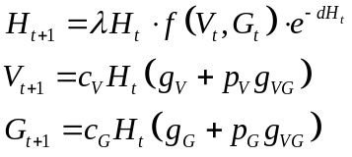
Here, H_{t}, V_{t} and G_{t} stand for the number of hosts and parasitoids at time t, where V and G can be interpreted as N. vitripennis and N. giraulti, respectively. is the intrinsic growth rate of hosts that escape parasitism, d is density dependence of the hosts, and 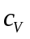and 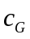 give the fecundity of the parasitoids V and G. 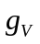, 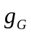 and 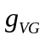 denote the fractions of hosts parasitized by only V, only G, or both. 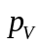 and 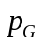 give the fraction of V and G in the offspring that emerge from multiparasitized hosts. Finally, 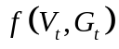 is the escape function, the fraction of hosts that escape parasitism by both species.
The escape function in a single parasitoid-host model is generally assumed to follow the negative binomial distribution. This assumes hosts are found in patches; parasitoids are distributed among the patches, after which they search randomly within the patch (May 1978). This is a good approximation for Nasonia wasps, which parasitize the pupae of flies in animal carcasses and birds’ nests, and rarely find a second patch with hosts to parasitize (Grillenberger et al. 2008), Because we are studying a system of two parasitoids with correlated distributions, we used a bivariate negative binomial distribution (Ives 1988b; Klopfer and Ives 1997), which has the following escape function:
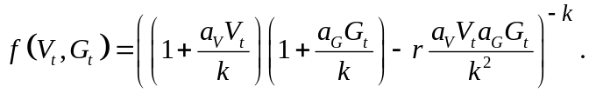
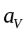 and 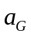 represent the two species’ respective search efficiencies, and k is the clumping parameter determining the degree of spatial aggregation of the hosts, and thereby the aggregation of encounters between hosts and parasitoids. If k = ∞, the negative binomial distribution reduces to a Poisson distribution (reflecting a lack of spatial aggregation in the hosts), and lower values of k denote stronger aggregation. The host-parasitoid dynamics are stable when k ≤ 1 (May 1978). Finally, r is the correlation between the distributions of the two parasitoids among the patches. A positive value for r denotes positive correlation in patch sharing between the two species, either because of interspecific attraction, or because both species use the same cues to find a patch. Conversely, a negative value indicates interspecific avoidance.
Even if the distributions of the two species over the patches are strongly overlapping (high r), this does not necessarily mean they share the same hosts within those patches. The covariance per host between the number of encounters of each species (number of hosts parasitized by each species), ρ, is given by
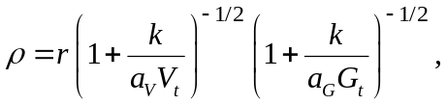
which decreases with k (so stronger aggregation leads to a higher covariance), and increases with the mean number of encounters for both species (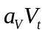 and 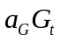, respectively).
Calculating the fractions, and is fairly straightforward. Because the total fraction of hosts encountered per species follows a negative binomial distribution, it follows that
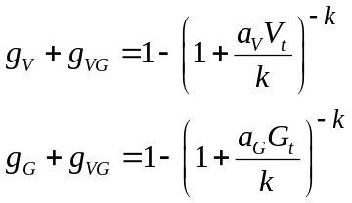
Because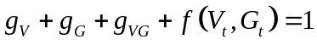, the fraction can be derived from equations (2) and (4):
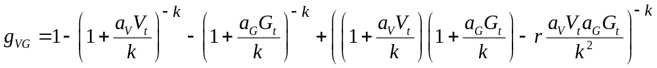
From this and (4), the remaining fractions and can be derived:
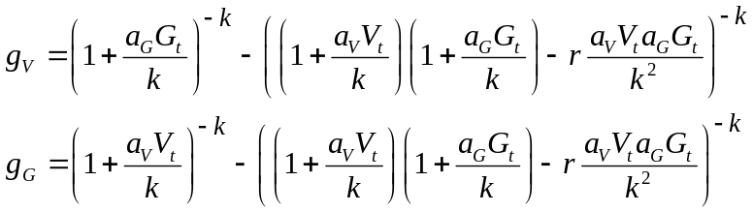
Between-adult competition
Adult female parasitoids compete over available hosts; we studied both symmetric and asymmetric competition (where one species is competitively inferior, as appears to be the case for N. giraulti). Both scenarios were studied using a numerical analysis and individual-based simulations. A parasitoid’s competitive ability is a combination of its search efficiency (,) and fecundity (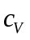,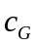); a difference in either can cause competitive asymmetry. We only study a difference in fecundity (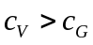, which appears to be the case in nature, Grillenberger et al. 2009) and assume both species have the same search efficiency; assuming competitive superiority in search efficiency instead is expected to yield the same results.
Within-host competition
In the above model, or parasitoids emerge from hosts that have been parasitized by only one species. In the case of multiparasitism, the fractions of V and G emerging are given by and , which are functions of the average number of eggs laid per host by both species, E_{V} and E_{G}. These can be approximated as follows:
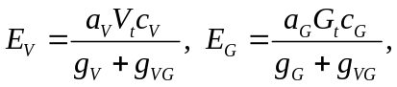
or the total number of eggs laid per species (the total number of encounters multiplied by the number of eggs laid per encounter), divided by the number of hosts encountered by this species.
The fractions of emerging offspring from multiparasitized hosts, and 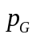, are then given by:
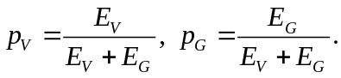
We analyzed the above system of equations numerically, determining whether there is a stable equilibrium where all three species coexist under either symmetric (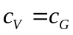) or asymmetric competition ().
The above equations make two critical assumptions: first, that the number of offspring emerging from parasitized hosts is always the same, regardless of how many parasitizations occurred. In Nasonia species superparasitism is common (Molbo and Parker 1996; Grillenberger et al. 2008; Grillenberger et al. 2009); and while females do avoid overcrowding and lay fewer eggs when superparasitizing (Wylie 1965; Werren 1980), more offspring emerge from superparasitized hosts than from single-parasitized ones (Molbo and Parker 1996). This suggests that hosts have a carrying capacity, but under natural conditions it can exceed the number of eggs laid by a single female.
The second assumption is that the larvae of V and G are competitively equal. While the relative competitive strengths of the two Nasonia species have not been studied, N. giraulti’s preference for multiparasitizing (Pérez-Vila et al, in revision) may reflect competitive superiority within the host.
We used individual-based simulations to relax both assumptions and their effects on coexistence; the details are described in the simulation setup below.

Simulation setup
We translated the above system into individual-based simulations for two purposes: to confirm the analytical results, and to study scenarios that are not analytically tractable. We ran 50 replicate simulations for 20,000 generations, after which we recorded for each individual simulation run which parasitoids persisted.
Distribution of encounters
For each host, the number of times it is encountered by both parasitoid species is drawn from a bivariate negative binomial distribution. This distribution is a compound of a bivariate gamma distribution with correlation coefficient r and a Poisson distribution; in biological terms, if r > 0 this means the distribution of the parasitoids among patches is correlated, but the parasitoids search randomly within patches, as seems to be the case for Nasonia (Grillenberger et al. 2009). We used the method of Minhajuddin et al. (2004) for multivariate gamma sampling to generate bivariate gamma values  and  with correlation coefficient r, which are combined with independent Poisson distributions to draw the final number of encounters with each parasitoid species.
Parasitism and within-host competition
For each encounter, the number of eggs laid by the parasitoid is drawn from a Poisson distribution with average or . After the parasitism phase, the survival rate of the eggs is determined by the total number of eggs (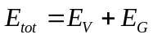) and the host carrying capacity 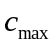. If 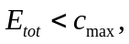 all larvae survive into adulthood. If 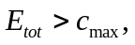 and both species have equal within-host competitiveness, the survival probability of each larva is 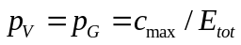.
Asymmetric within-host competition is implemented by giving G an advantage 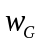 when multiparasitizing, giving its offspring a higher probability to survive larval competition until emergence, but only when sharing a host with V. In this case, the survival probabilities in multiparasitized hosts are as follows:
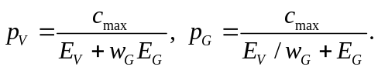
In contrast with the numerical analysis of the equations, where the probabilities and are approximated by the average number of eggs per host, in the simulations these can be calculated exactly based on the actual number of parasitoids that parasitized each host. This can give a more accurate view on how within-host competition plays out, and whether coexistence is possible.
Host and parasitoid reproduction
After parasitism, the number of hosts that escaped parasitism is subject to natural mortality (density dependence). The number that survive after this is multiplied by and rounded down, giving the size of the host population in the next generation.
For all parasitized hosts, the number of eggs that develop to adulthood are summed to make up the two parasitoid population sizes in the next generation.

Results

Numerical analysis
For the simplest case, symmetric competition where the two parasitoid species have the same fecundity (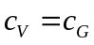), coexistence is possible no matter how strongly correlated the distributions are, as long as the host growth rate λ is high enough to sustain the host population (Figure 1a-d).
Next, we looked at the conditions for coexistence under asymmetric competition by introducing a fecundity difference (which seems the case for N. giraulti and N. vitripennis). When the inferior competitor has a small fecundity disadvantage (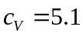, 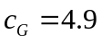) the conditions for coexistence are far more restrictive, especially when the distributions are strongly correlated (Figure 1e-h). Increasing the fecundity disadvantage for G (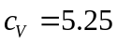, 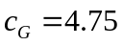) restricts coexistence even further (Figure 1i-l). In general, coexistence is favoured by a high host reproductive rate and by strong host aggregation (low k). This last result is consistent with the general finding that strong aggregation of encounters promotes coexistence (Ives 1988a; Klopfer and Ives 1997).
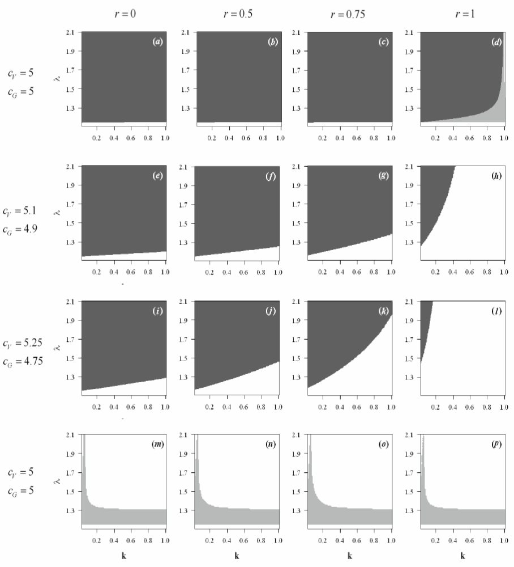
Figure 1. Numerical stability analysis of the one-host two-parasitoid system for different values of the correlation coefficient r and the parasitoid fecundities and , plotted against the aggregation parameter k and host growth rate λ. White area: unstable; dark grey: stable; light grey: neutrally stable. In all figures, 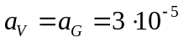, 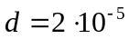. (a)-(d) 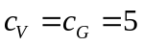. (e)-(h): small difference in fecundity, 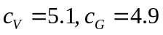. (i)-(l): large fecundity difference, 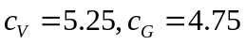.(a)-(l): 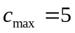. (m)-(p): no fecundity difference and no within-host competition (all eggs laid emerge as adults), .

Lastly, we looked at the unrealistic scenario of removing within-host competition by modifying the model so all eggs laid by the parasitoids emerge as adults:
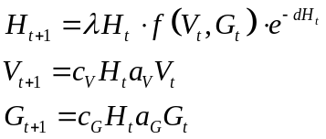
Because there is no competition between larvae within the host, the correlation between the distributions (r) has no effect on the stability of coexistence. More importantly, the two-parasitoid equilibrium is never stable, although there is neutral stability for low host growth rate (Figure 1m-p); but even then, long-term coexistence is not expected because stochastic fluctuations in parasitoid abundances are expected to drive one of the parasitoid species extinct. Simulations confirm that there is never stable coexistence of the hosts and both parasitoids in this scenario (see the effect of increasing in the next section).

Simulation results
The simulation results generally confirm the results shown in Figure 1 and discussed in the previous section (Figure 2a, 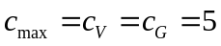). Although coexistence is not possible for all combinations of k and r, as Figure 1a-d shows, there is a still wide parameter range for both parameters allowing coexistence of the two parasitoids. Coexistence is promoted by low k (strong aggregation of encounters) and low r (weakly overlapping distributions). When one species is competitively superior, coexistence is still possible but limited to a much narrower range for both k and r (Figure 2b), confirming the numerical results shown in Figure 1e-l.
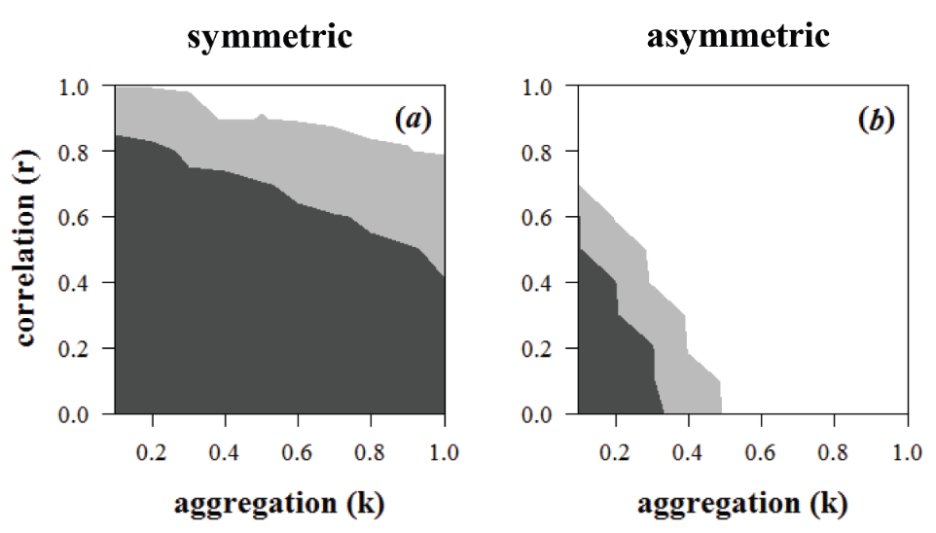
Figure 2. Simulation results showing whether the two parasitoids coexist after 20,000 generations, plotted against k and r. Each parameter combination is replicated 50 times. White: never coexistence; dark grey: always coexistence; light grey: sometimes coexistence. (a): 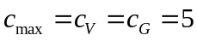; (b): = 5, = 5.25, = 4.75. In both figures, , , λ = 1.3.

Severity of within-host competition
Now we go beyond the results of the numerical analysis, looking at the effect of varying the level of within-host competition by changing the within-host carrying capacity . Decreasing within-host competition (increasing ) makes coexistence less likely; this effect is especially strong if one species (G) has a fecundity disadvantage (Figure 3a-d for parasitoids with identical trait values, and Figure 3e-h when G has a 10% fecundity disadvantage). The most likely explanation for this is that higher leads to higher parasitoid abundances and lower host abundance, which increases competition between adult parasitoids. In fact, low within-host competition (high ) can destabilize the system entirely, making coexistence of the host with even one parasitoid species impossible (data not shown). Both of these destabilizing effects are most pronounced when host aggregation is weak (i.e. high values of k).
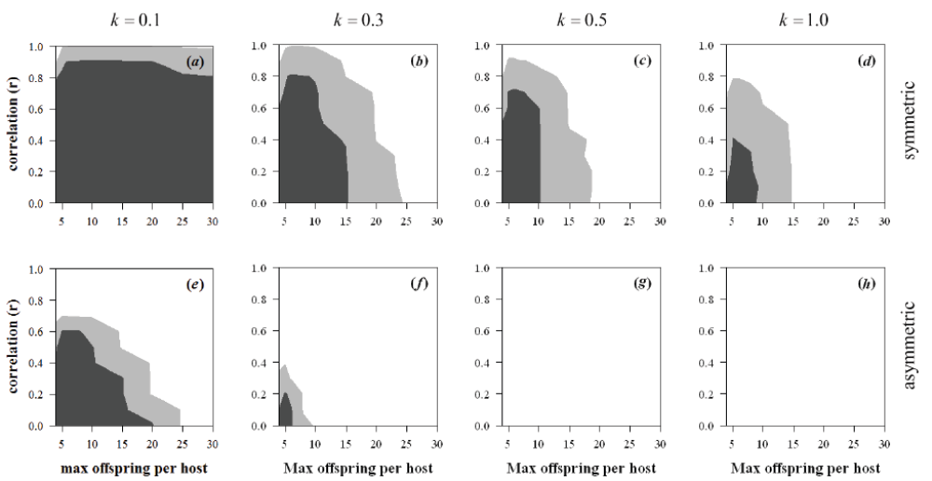
Figure 3. Simulation results for different values of . (a)-(d): , (e)-(h): = 5.25, = 4.75. (a), (e): k = 0.1; (b), (f): k = 0.3; (c), (g): k = 0.5; (d), (h): k = 1. In all figures, , , λ = 1.3. Colours denote the same outcomes as in Figure 2.

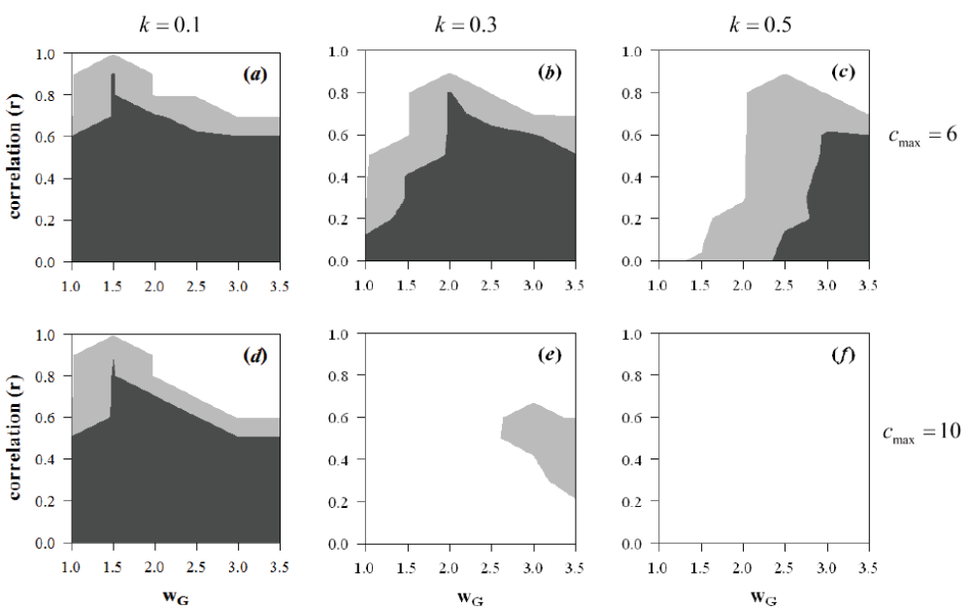
Figure 4. Simulation results for different values of w_{G}. In all figures, = 5.25, = 4.75, , , λ = 1.3. (a)-(c): = 6; (d)-(f): = 10. (a), (d): k = 0.1; (b), (e): k = 0.3; (c), (f): k = 0.5. Colours denote the same outcomes as in Figure 2.

Within-host advantage
Last, we studied the effect of a within-host competitive advantage () for G, which could compensate for its fecundity disadvantage. Again we chose the fecundities , , and studied values of from 1.5 - 3.5 and two different values of the within-host carrying capacity (6 and 10). We find that a within-host advantage can indeed facilitate coexistence (Figure 4), particularly for intermediate values of . If the within-host advantage is too weak, it cannot compensate for the fecundity disadvantage; on the other hand, a very strong advantage makes it possible for G to outcompete V. This last effect is especially true when the distributions are strongly correlated (high r), because a higher correlation means that the two species will share the same hosts more often. This can be seen very clearly in Figure 4e, where coexistence is only possible for an intermediate correlation. If it is too low, the two species will not interact enough to make the within-host advantage pay off, but if it is too high, G’s advantage can drive V extinct.

Discussion
This paper aimed at studying the role of within-host competition on the coexistence of two parasitoid species sharing a host. We find three general patterns: first, coexistence is promoted by weak between-adult interspecific competition (low distribution overlap). Second, the opposite pattern was found for within-host competition: coexistence is promoted by strong within-host competition. Finally, competitive asymmetry reduces coexistence when the asymmetry is at the adult level; asymmetry in within-host competition, on the other hand, can both promote and reduce coexistence.
Leaving out any other factors first, the results of our numerical analysis are in line with previous studies on the effect of aggregation and correlated distributions (Kakehashi et al. 1984; Klopfer and Ives 1997): coexistence is promoted by a high level of aggregation in the distribution (low k), but reduced by overlap in the parasitoids’ distributions; this second effect is especially strong when there is competitive asymmetry between the species. All these results are in agreement with previous models that do not allow for interspecific host sharing (Ives 1988b; Klopfer and Ives 1997).
While the results of our numerical analysis suggest that coexistence of two competitively equal parasitoids is always possible when r < 1, and often even when r = 1 (complete overlap), the simulation results show that coexistence is more restricted: strongly overlapping distributions (r ≥ 0.8) never support coexistence, and coexistence is even further limited when the host distribution is not very strongly aggregated (for higher values of k). This discrepancy can be explained by noting that in our equations, the values for the survival probabilities and are only an approximation of the actual fractions. The simulation results are therefore a more accurate reflection of whether coexistence is possible.
In addition to correlation in host encounters and host aggregation, we looked at two more factors that have previously received much less attention: severity and asymmetry of within-host competition. The former gives the counterintuitive result that stronger within-host competition promotes coexistence. Our explanation for this is that increasing the within-host carrying capacity increases parasitoid abundances, which in turn decreases host abundance. This increases interspecific adult competition, making coexistence less feasible. So, while increasing between-adult competition reduces coexistence, increasing within-host competition promotes it.
This latter result also gives an explanation for why interspecific host sharing is very rare in nature. Interspecific host sharing is only possible when the offspring of a single female do not consume the entire host (Miller 1982; Magdaraog et al. 2012; Harvey et al. 2013); in terms of our model, it is only possible when within-host competition is weak (high ). However, this same condition also severely impairs coexistence. Stable coexistence is unlikely when within-host competition is weak, and more likely when within-host competition is strong. Strong competition leads to strong selection for mechanisms to eliminate heterospecific competitors, which is indeed far more commonly found in nature than interspecific resource sharing.
Second, we found that in case of competitive asymmetry (one species having a lower fecundity) an advantage in within-host competition could compensate for its competitive disadvantage and restore coexistence. However, it is only really effective when within-host competition is severe. If within-host competition is relatively weak, the effect of a within-host advantage is decreased, and hence coexistence is less likely. If two parasitoids can share the same host without overcrowding (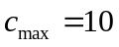 in Figure 4) coexistence is only possible when the host distribution is very strongly aggregated. Furthermore, coexistence in all cases is mostly restricted to values of r that are low to moderate, unless there is very strong aggregation (k = 0.1).

Implications for Nasonia coexistence
Our model was inspired by the coexistence of two Nasonia species competing for the same hosts (blowfly larvae in bird nests), where N. giraulti is clearly the inferior competitor and the species’ distributions are very strongly correlated; N. giraulti is never found in a nest by itself, but only when N. vitripennis is also present (Grillenberger et al. 2008).
There are several field data sets available to estimate the values of k. For N. vitripennis the two reported values for natural nests are similar (k ≈ 0.72 for field data on only N. vitripennis, Grillenberger et al. 2008,; k ≈ 0.81 for field data on N. vitripennis and N. giraulti, Grillenberger et al. 2009). It is harder to estimate a value for N. giraulti, because its abundance in the field is much lower; but Grillenberger et al (2009) gives an estimate of k ≈ 0.1. If this is correct, this means the encounters of N. giraulti are more aggregated than those of N. vitripennis. However, it should be noted that these estimates are based on data on emerged offspring, not on the actual distribution of encounters. There may be a discrepancy between these if not all parasitizations are successful, and this will particularly be the case if N. giraulti is facilitated by N. vitripennis. For this reason, and because the field abundance of N. giraulti is much lower, its encounters may only appear to be more aggregated. Because the bivariate negative binomial distribution only has one value for k, it is difficult to estimate the correlation coefficient r with the available data. Using a weighted average of the two values, k ≈ 0.61, we find an estimate of r ≈ 0.8. This is consistent with the observation that N. giraulti is always found co-occurring in nests with N. vitripennis and never by itself, which indicates r must be high to very high.
Our results show that the first of our hypothetical explanations for coexistence, weak within-host competition, does not hold up at all; to the contrary, weak within-host competition reduces the opportunities for coexistence. The second, a within-host advantage, only has a limited effect in promoting coexistence, and mostly for intermediate distribution overlap. Given the strong overlap between N. vitripennis and N. giraulti in the field, this too seems unlikely to be the explanation for how N. giraulti can persist.
Evidently, our model may lack something else of vital importance to understanding coexistence of these two species, so we explored several possibilities. First, we modeled competitive asymmetry by introducing a difference in fecundity, and assumed they have the same search efficiency; we know from field data that N. giraulti has a lower fecundity than N. vitripennis (Grillenberger et al. 2009; Daoust et al. 2012), but nothing is known about their respective search efficiencies. We tested the robustness of our results with regard to this assumption, and our results indicate that a competitive asymmetry in search efficiency would yield largely the same patterns, though coexistence is more slightly restricted than in our general model (results not shown).
Second, our model assumes that all hosts are equal in terms of quality, and all have the same within-host carrying capacity. In nature, host quality is highly variable, depending on characteristics such as species, size or developmental stage. Adding variation in quality to our simulations (where each host’s individual carrying capacity was drawn from a normal distribution with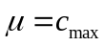) did affect coexistence depending on the value of : for low values, adding variation decreased coexistence, while the opposite was true for higher values of . The destabilizing effect of low within-host competition is somewhat smaller when variation in quality is taken into account, but the overall pattern still holds.
Finally, our model makes two critical assumptions: first, that encounters within patches are random; and second, that females always lay the same number of eggs, regardless of whether the host is fresh or already parasitized by either species. Regarding the first assumption, while field data on the distribution of foundresses over hosts showed no evidence for preference for or against hosts used by other females (Grillenberger et al. 2009), laboratory experiments have shown that N. vitripennis avoids superparasitism when given the choice between fresh and parasitized hosts (Ivens et al. 2009, S. Pérez-Vila et al, in revision). The same is true for N. longicornis, and a host choice experiment with N. vitripennis and N. longicornis showed they both avoid multiparasitism even stronger than superparasitism (Ivens et al. 2009). The behaviour of N. giraulti is very different: it appears to have no aversion to superparasitizing and a preference for multiparasitizing. Taking all of these data together, it appears unlikely that females use hosts within patches indiscriminately, as our model assumes. How nonrandom use of hosts – either through avoiding or through preferring super- / multiparasitism – would affect coexistence is an open question. Avoidance of parasitized hosts would reduce within-host competition (although it would also reduce the number of available hosts, increasing adult competition), potentially lowering the negative effects of sharing a patch. On the other hand, it would lead to a more even distribution of encounters, reducing the level of aggregation (higher k) as well as reducing within-host competition. Both of these effects have been shown in this study to reduce coexistence rather than promote it. Whether either scenario would promote or reduce coexistence requires further study.
The second assumption, that females lay equal numbers of eggs in parasitized and unparasitized hosts, is likely to be more critical. There is ample evidence that N. vitripennis adjusts its clutch size to lay fewer eggs when superparasitizing (Wylie 1967; Werren 1980; Werren 1984; Ivens et al. 2009). Similar data is unfortunately unavailable for N. giraulti, but consistent with their apparent preference for multiparasitizing: they lay more eggs when multiparasitizing than N. vitripennis (Pérez-Vila et al, in revision). A version of the simulations in which both species lay fewer eggs in parasitized hosts, either by conspecifics or heterospecifics, did not yield any results suggesting this alone would improve coexistence. Rather than reducing competition, this scenario leads to lost opportunities for superparasitizing females. The setup of our current model does not allow for females to look for a more suitable host after rejecting an unsuitable one, or to offset the costs of laying fewer eggs in parasitized hosts by laying more eggs in unparasitized ones. A scenario that does allow for either of these two behaviours is definitely more realistic, but is beyond the scope of our current study. A model explicitly allowing avoidance of or preference for parasitized hosts, through either oviposition or clutch size decisions, is a necessary direction for further study.
Our model incorporating within-host competition was inspired by the Nasonia system. While the factors we studied seem unsuccessful in explaining coexistence in this particular system, they apply to multiparasitoid-host systems in general. Within-host competition has been a neglected component of multiparasitoid-host models; this is the first model to look at its effects in detail, and we find that it can have a dramatic effect on whether coexistence of two parasitoid species is possible.

Acknowledgements
We thank Bregje Wertheim and Leo Beukeboom for their insightful comments on this manuscript. The research of EvV and RSE is supported by the Netherlands Foundation for Scientific Research (NWO)

References
Breeuwer, J. A. J., and J. H. Werren. 1990. Microorganisms associated with chromosome destruction and reproductive isolation between two insect species. Nature 346:558-560.
Charnov, E. L., and S. W. Skinner. 1984. Evolution of host selection and clutch size in parasitoid wasps. Florida Entomologist 67:5-21.
Chau, N. N. B., and K. Maeto. 2008. Intraspecific larval competition in Meteorus pulchricornis (Hymenoptera : Braconidae), a solitary endoparasitoid of lepidopteran larvae. Applied Entomology and Zoology 43:159-165.
Crespo, J. E., and M. K. Castelo. 2009. Insights to host discrimination and host acceptance behaviour in a parasitoid (Diptera: Asilidae): Implications for fitness. Journal of insect physiology 55:1072-1078.
Daoust, S. P., J. Savage, T. L. Whitworth, M. Belisle, and J. Brodeur. 2012. Diversity and abundance of ectoparasitic blow flies Protocalliphora (Diptera: Calliphoridae) and their Nasonia (Hymenoptera: Pteromalidae) parasitoids in tree swallow nests within agricultural lands of Southern Quebec, Canada. Annals of the Entomological Society of America 105:471-478.
Darling, D. C., and J. H. Werren. 1990. Biosystematics of Nasonia (Hymenoptera: Pteromalidae): two new species reared from birds nests in North-America. Annals of the Entomological Society of America 83:352-370.
Dorn, S., and N. E. Beckage. 2007. Superparasitism in gregarious hymenopteran parasitoids: ecological, behavioural and physiological perspectives. Physiological Entomology 32:199-211.
Fisher, R. C. 1963. Oxygen requirements and physiological suppression of supernumerary insect parasitoids. Journal of Experimental Biology 40:531-540.
Flanagan, K., S. West, and H. Godfray. 1998. Local mate competition, variable fecundity and information use in a parasitoid. Animal Behaviour 56:191-198.
Godfray, H. C. J. 1994. Parasitoids: behavioural and evolutionary ecology. Princeton University Press, Princeton.
Grillenberger, B. K., T. Koevoets, M. N. Burton-Chellew, E. M. Sykes, D. M. Shuker, L. V. De Zande, R. Bijlsma, J. Gadau, and L. W. Beukeboom. 2008. Genetic structure of natural Nasonia vitripennis populations: validating assumptions of sex-ratio theory. Molecular ecology 17:2854-2864.
Grillenberger, B. K., L. van de Zande, R. Bijlsma, J. Gadau, and L. W. Beukeboom. 2009. Reproductive strategies under multiparasitism in natural populations of the parasitoid wasp Nasonia (Hymenoptera). Journal of Evolutionary Biology 22:460-470.
Hackett-Jones, E., C. Cobbold, and A. White. 2009. Coexistence of multiple parasitoids on a single host due to differences in parasitoid phenology. Theoretical Ecology 2:19-31.
Hagvar, E. B. 1988. Multiparasitism of the green peach aphid, Myzus persicae - competition in the egg stage between Aphidius matricariae and Ephedrus cerasicola. Entomologia Experimentalis et Applicata 47:275-282.
Hartley, S., and B. Shorrocks. 2002. A general framework for the aggregation model of coexistence. Journal of Animal Ecology 71:651-662.
Harvey, J. A., E. H. Poelman, and T. Tanaka. 2013. Intrinsic inter- and intraspecific competition in parasitoid wasps. Annual Review of Entomology, Vol 58 58:333-352.
Hogarth, W. L., and P. Diamond. 1984. Interspecific competition in larvae between entomophagous parasitoids. American Naturalist 124:552-560.
Ivens, A. B. F., D. M. Shuker, L. W. Beukeboom, and I. Pen. 2009. Host acceptance and sex allocation of Nasonia wasps in response to conspecifics and heterospecifics. Proceedings of the Royal Society B-Biological Sciences 276:3663-3669.
Ives, A. R. 1988a. Aggregation and the coexistence of competitors. Annales Zoologici Fennici 25:75-88.
Ives, A. R. 1988b. Covariance, coexistence and the population dynamics of two competitors using a patchy resource. Journal of theoretical biology 133:345-361.
Jaenike, J. 1978. On optimal oviposition behavior in phytophagous insects. Theoretical population biology 14:350-356.
Kakehashi, N., Y. Suzuki, and Y. Iwasa. 1984. Niche overlap of parasitoids in host-parasitoid systems: its consequence to single versus multiple introduction controversy in biological control. Journal of Applied Ecology 21:115-131.
Klopfer, E. D., and A. R. Ives. 1997. Aggregation and the coexistence of competing parasitoid species. Theoretical population biology 52:167-178.
Kon, R., and S. J. Schreiber. 2009. Multiparasitoid-host interactions with egg-limited encounter rates. SIAM Journal on Applied Mathematics 69:959-976.
Lane, S. D., C. M. St Mary, and W. M. Getz. 2006. Coexistence of attack-limited parasitoids sequentially exploiting the same resource and its implications for biological control. Annales Zoologici Fennici 43:17-34.
Magdaraog, P. M., J. A. Harvey, T. Tanaka, and R. Gols. 2012. Intrinsic competition among solitary and gregarious endoparasitoid wasps and the phenomenon of resource sharing. Ecological Entomology 37:65-74.
May, R. M. 1978. Host-parasitoid systems in patchy environments: a phenomenological model. Journal of Animal Ecology 47:833-844.
May, R. M., and M. P. Hassell. 1981. The dynamics of multiparasitoid-host interactions. American Naturalist 117:234-261.
Miller, J. C. 1982. Life history of insect parasitoids involved in successful multiparasitism. Oecologia 54:8-9.
Minhajuddin, A. T. M., I. R. Harris, and W. R. Schucany. 2004. Simulating multivariate distributions with specific correlations. Journal of Statistical Computation and Simulation 74:599-607.
Molbo, D., and E. D. Parker. 1996. Mating structure and sex ratio variation in a natural population of Nasonia vitripennis. Proceedings of the Royal Society B-Biological Sciences 263:1703-1709.
Nicholson, A. J., and V. A. Bailey. 1935. The balance of animal populations, part 1. Proceedings of the Zoological Society of London 3:551-598.
Porter, E. E., and B. A. Hawkins. 2003. The influence of varying spatial heterogeneity on the refuge model for coexistence of specialist parasitoid assemblages. Oikos 100:241-250.
Rivero, A., and S. A. West. 2005. The costs and benefits of host feeding in parasitoids. Animal Behaviour 69:1293-1301.
Rivero, A., and S. A. West. 2002. The physiological costs of being small in a parasitic wasp. Evolutionary Ecology Research 4:407-420.
Sykes, E. M., T. M. Innocent, I. Pen, D. M. Shuker, and S. A. West. 2007. Asymmetric larval competition in the parasitoid wasp Nasonia vitripennis: a role in sex allocation? Behavioral Ecology and Sociobiology 61:1751-1758.
van Alphen, J. J. M., and M. E. Visser. 1990. Superparasitism as an adaptive strategy for insect parasitoids. Annual Review of Entomology 35:59-79.
van Alphen, J. J. M., M. E. Visser, and H. W. Nell. 1992. Adaptive superparasitism and patch time allocation in solitary parasitoids: searching in groups vs sequential patch visits. Functional Ecology 6:528-535.
van Baaren, J., G. Boivin, and J. P. Nénon. 1994. Intraspecific and interspecific host discrimination in two closely related egg parasitoids. Oecologia 100:325-330.
Werren, J. H. 1984. Brood size and sex ratio regulation in the parasitic wasp Nasonia vitripennis (Walker) (Hymenoptera: Pteromalidae). Netherlands Journal of Zoology 34:123-143.
Werren, J. H. 1980. Sex ratio adaptations to local mate competition in a parasitic wasp. Science 208:1157-1159.
Whiting, A. R. 1967. The biology of the parasitic wasp Mormoniella vitripennis [=Nasonia brevicornis] (Walker). Quarterly Review of Biology 42:333-406.
Wylie, H. G. 1967. Some effects of host size on Nasonia vitripennis and Muscidifurax raptor (Hymenoptera: Pteromalidae). Canadian Entomologist 99:742-748.
Wylie, H. G. 1965. Discrimination between parasitized and unparasitized house fly pupae by females of Nasonia vitripennis (Walk.) (Hymenoptera: Pteromalidae). Canadian Entomologist 97:279-286.

